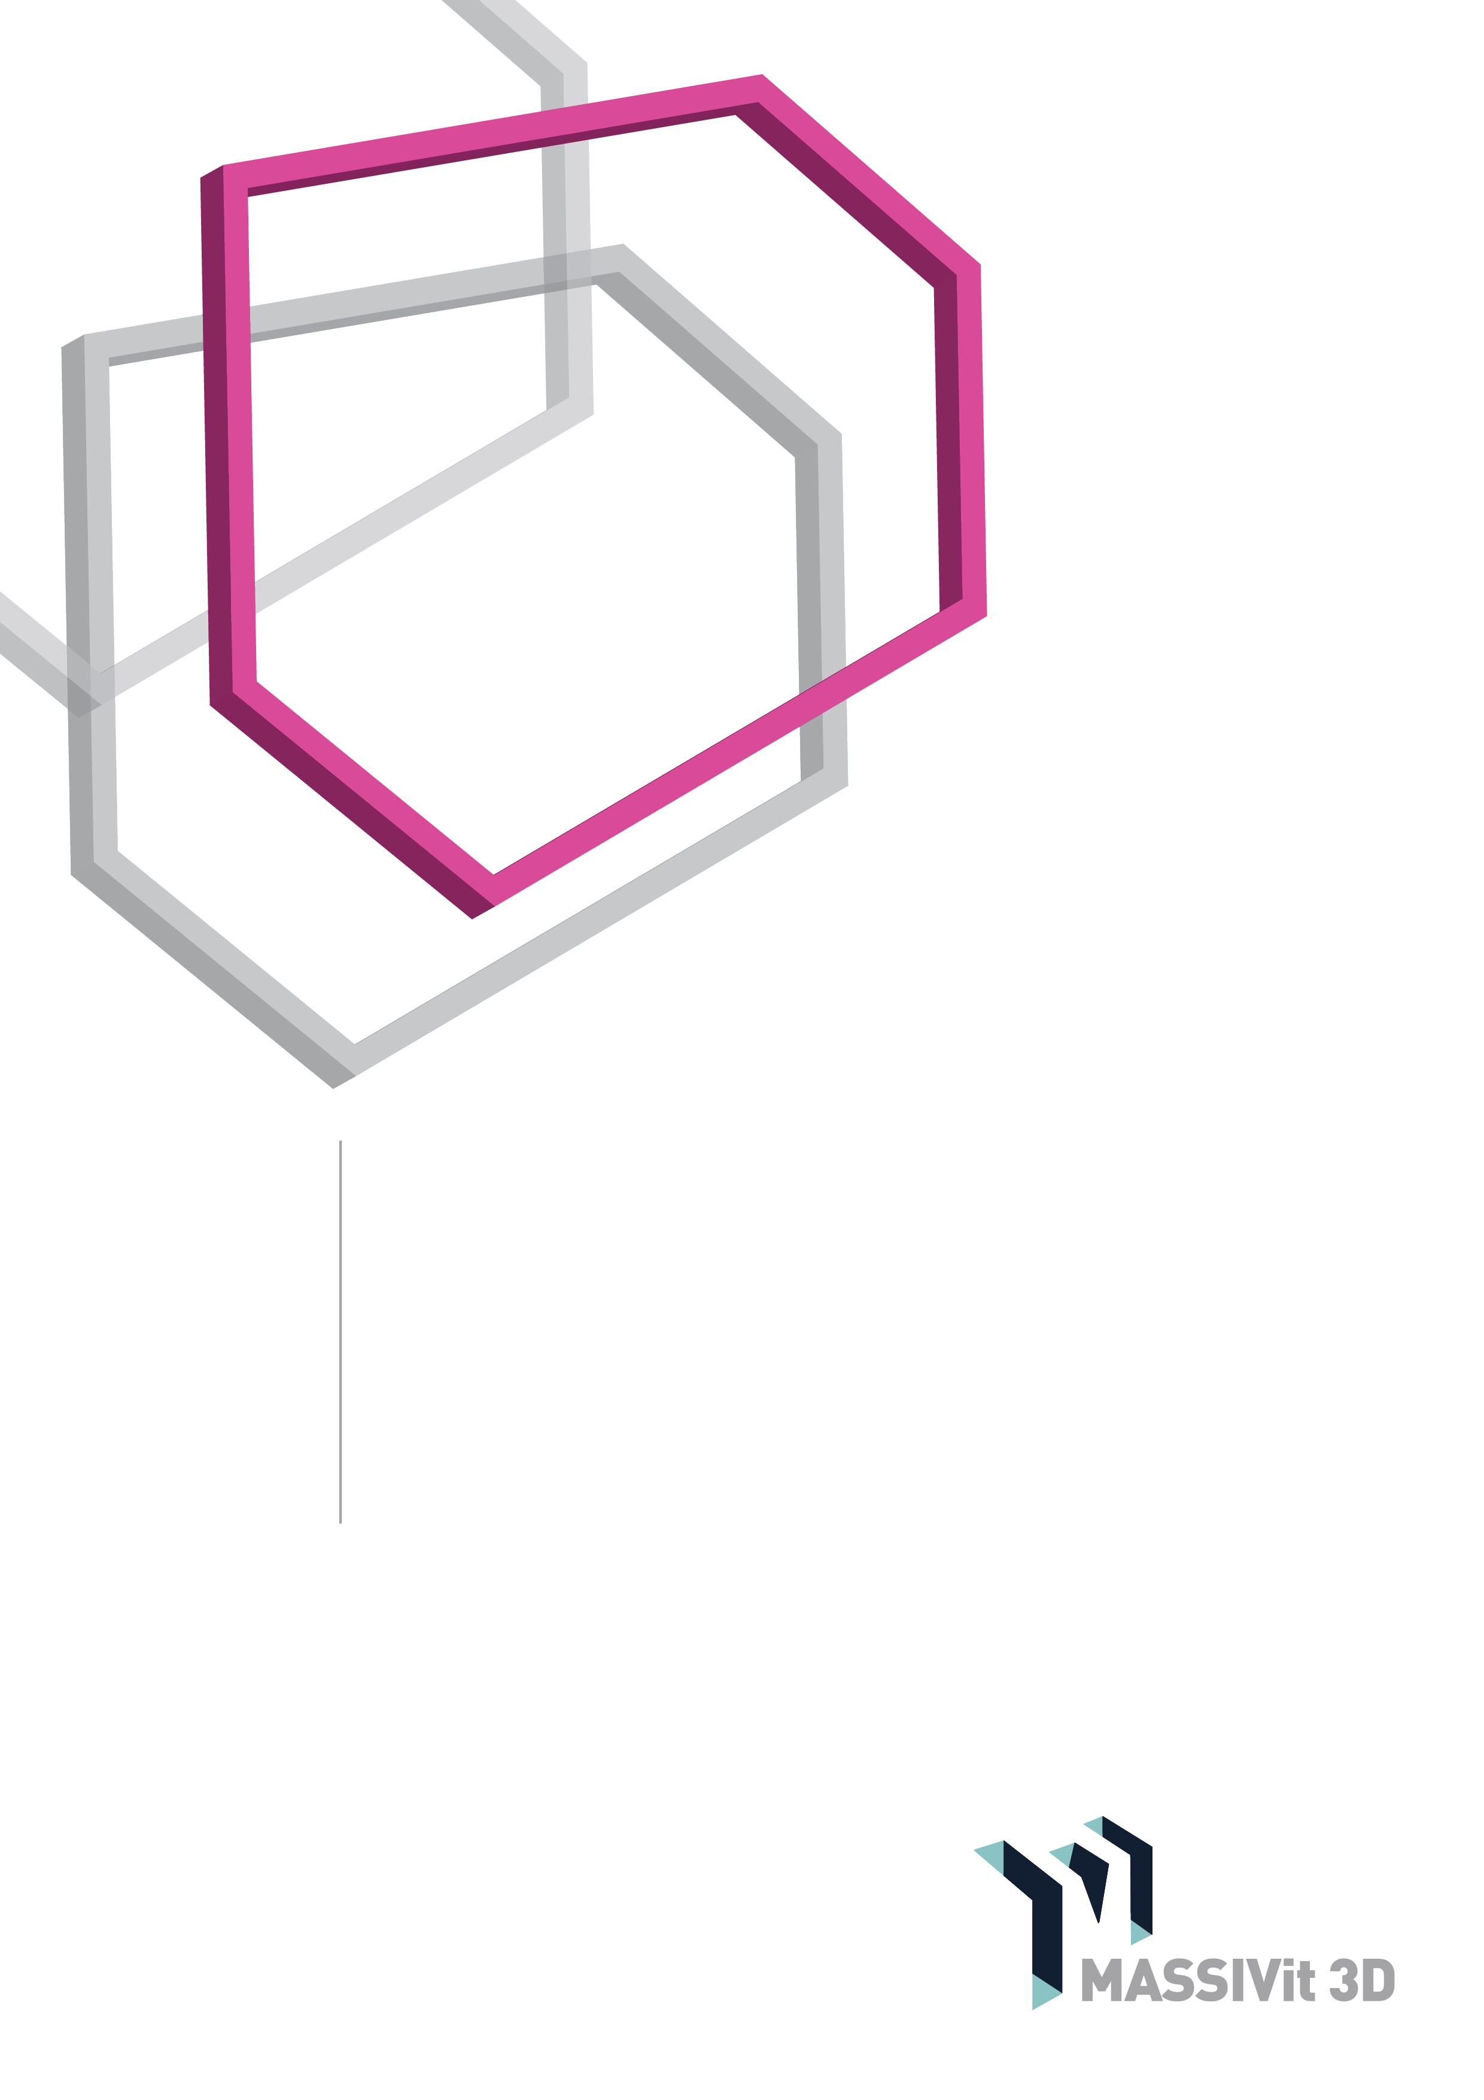lk

Massivit

HOW-TO GUIDE

Hot coatings: Hot Polyurethane and Hot Polyuria.

[www.massivit.com](http://www.massivit.com)

The information provided in this document is believed to be accurate and reliable. However, no responsibility is assumed by MASSIVit 3D for the use of this document or for the performance of any materials mentioned. MASSIVit 3D reserves the right to make changes to this document or any material included in it at any time and without notice.

Published on December 2017

© Copyright MASSIVit 3D 2017

**Introduction**

3D printing, at most methods, is characterized by visible print layers, that in some cases there is a need to sooth and hide. One way to achieve smooth surface of the printed Massivit model is to coat it with Hot Coatings.

Hot coatings are a two-part, sprayable, coating materials. Those can be based on polyurethane, or polyuria, or a mixture of both. Once applied, those type of coatings will cure within seconds to a hard surface.

When applied properly, itprovides a good surface addition to Massivit prints. The use of such coating method provides a close-to-perfect cover and hides the print layers, without the need for prolonged polishing. In addition to this, coating a model with hot coating improves its durability to external conditions; depending on the type of material, it can make it less brittle and improve fire resistance. Some Hot coatings, especially flexible-hot-polyuria, will turn the model to virtually unbreakable.

This guide will use two specific products for demonstrating the operation of applying hot coating but is valid for a wide range of similar materials. The specific materials that are used in this document are:

* EasyFlo Spray FR- by polytek, as an example for **Hot rigid polyurethane**
* XS 350 – by line-x, as an example for **Hot flexible polyuria**

**When to use**

Although hot coatings can be used on any model, we recommend using it mainly on big objects that need to withstand extreme outdoor conditions and are to be seen from far. The reason for these conditions is that the material application is somewhat complicated and requires skill and practice.

Listed below a table of advantages and disadvantages that can assist the use in deciding if the method is right for a project.

|  |  |
| --- | --- |
| Hot coatings advantages | Hot coatings disadvantages |
| Adds strength to the model, up to the point that certain coatings will make the model virtually unbreakable. | difficult to apply and requires special equipment and expertise. |
| Enhance the models’ resistant to all weather conditions | May have Grained texture (orange peel like) |
| Enhance the models’ Fire-retardant qualities. | Non-transparent, don’t fit for used on internally lighted models. |
| Covers the printed layers and eliminate the need for polishing | Might eliminate small details |

**Materials properties**

Each coating material in this family has its own characteristics; before starting a project, it is recommended to get advice on which material to choose, read the data sheet carefully and choose accordingly. The table below is an example of comparison between two types of materials:

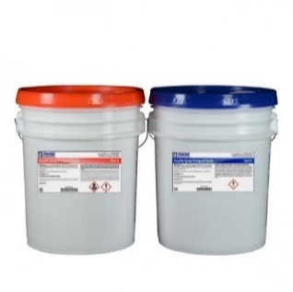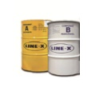

|  |  |  |
| --- | --- | --- |
|  | **XS 350** | **EasyFlo Spray FR** |
| Mix Ratio | 1A:1B by Volume | 1A:1B by Volume, or 100A:90B by Weight |
| Color of mixed material | Off-white- pigment can be added | Off-white- pigment can be added |
| Pot Life, min | 3 to 6 sec. | 5 Seconds |
| Shore Hardness | D60 | 75D |
| USFDA | USFDA Coating Regulations for Incidental-Food-Contact Applications | No |
| fire-retardant | No | UL-94 (V-0) fire-retardant plastic |
| Can be polished | Very hard to polished | Yes |
| Impact resistance | Extreme (up to small firearms) | Some |
| Can be painted | Yes | Yes |
| Spray equipment | High pressure heated reactor only – graco  h-XP2 | Graco E-10 or cartridge gun |

**How to use**

Hot coating materials react extremely quickly. Therefor a simple spray gun cannot be used for applying them. The two parts of the material should be mixed only upon exiting the spray gun, so it is essential to use a special spraying system.

Spraying systems suitable forhot coating, can vary to two main types of categories:

1. Portable spray gun with disposable cartridge and disposable tip.
2. A reactor system, which heats up the material & circulate it back and forth to a special gun. The gun in turn, can be air- purged to enable continuous work.

Tip

Since the use of the spray systems requires high skill set, we recommend that you give the first few jobs to an external contractor. Only upon getting satisfactory results, invest in capital equipment

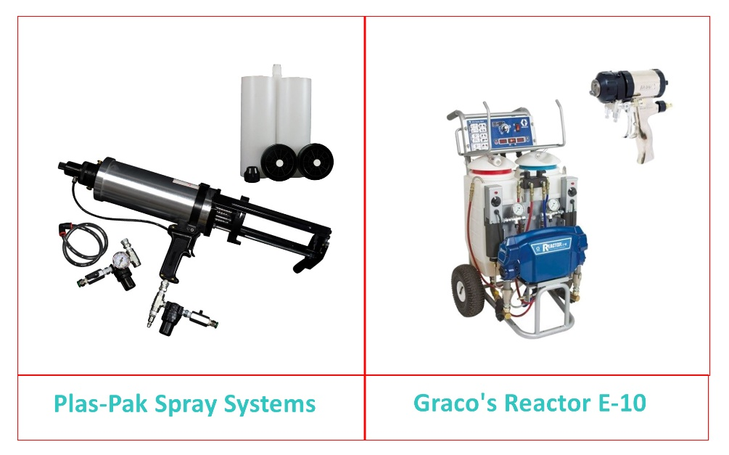

Although portable spray guns are cheaper we recommend using a reactor system due to the following reasons:

* Reactor system is capable to heat the material, thus improving its flow and viscosity. Some hot materials must be heated and cannot be apply by a simple cartridge gun.
* A reactor system has a variety of pressures options that can be set to the needs of the specific model.
* Spraying using a cartridge gun will always give Inferior and grainy surface compared to reactor.
* Reactor system have a capacity to load large amounts of material in its containers- enable continuous work without the need for reloading

It is also recommended to use an experienced outside contractor for occasional jobs, since good results requires high skills and expensive equipment.

Before starting to spray make sure that everything is ready for comfortable and safe work; prepare the model, the workspace and the gear in advance.

**Before starting to work**

**Workspace**

Workspace for coating the models should be large enough to allow a person to walk around the model, reaching it from all sides with at least one-meter distance.

The material of Hot spray is not a regular paint but a hard plastic that may damage any surface or equipment it meets; workspace walls and floor should be covered with disposable plastic sheets.

Spraying should be done in a closed space with air extraction in accordance to all local regulations. Before usage, read the materials’ MSDS data sheet and in any case, avoid spraying the material close to people without full protective gear.

**Protective gear**

The person which performs the spraying and anyone else in the proximity of it, must in all time, wear full protective gear that includes: full protective suit that covers the head & shoes, gloves and full-face respiratory mask which includes protection of face and eyes. Air filters should meet the manufacturer's requirements according to the safety data sheet. In any case don’t work with any material without rending its safety data sheet.

**Preparing the model**

The model surface should be clean of impurities, dust and polishing residues. If there are large defects- it is advised to polish them out before the coating begin.

The surface of the model must be completely clear from any moisture or water.

The purity of the surface model is exceptionally important as moisture or dirt can easily cause blistering effect. Polyurethane coating is more sensitive to moisture while polyuria will not.

As a rule of thumb, it is better to coat the model in its entirety rather than in parts since it can add strength the connection points. However, if the model is especially large, or exceptionally complex, it may be better to coat it in parts.

Above are blisters caused by water and moisture on the surface of the printed model.

**Spraying emphasis**

Check the compressor that feeds the spraying system. It must be free of water. Use a water trap for extra assurance.

Upon starting, spry the first few times on a disposable plastic sheet and not on the model itself, so to avoid damaging the printed model in case there is a problem. This step will also assist in adjusting the pressures for getting the desired effect of coating.

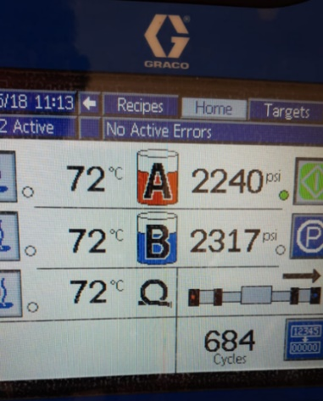Adjust the compressor pressures and heat until you get the desired result. Note that the exact degree of heat and point of pressure vary by type of spraying system, climatic conditions and personal preference; it is essential to experiment before the beginning a spraying session. (see image)

Even though hot coatings harden in seconds, allow 2 to 3 minutes for the coating to cool down and dry up entirely before touching or moving the model.

Here you can see the settings being used in spraying XS-350. Note the temperature and pressure

**Examples of spraying**

At this section we will review projects, one using Hot Polyurethane, pigmented with grey UV protecting paint,

and the other using Hot Polyuria, pigmented with black paint.

The model is fixed in place in a way that a person can walk around it. All the walls & floor are covered in disposable plastic sheet.

It is important to spray from a variety of angles. Note that all the people wear full protective gear.

After the main spraying, we flipped the model to reach especially difficult places. Plan the spraying sequence in advance. Notice the spray on the wall done to examine the material and pressures before spraying the model.

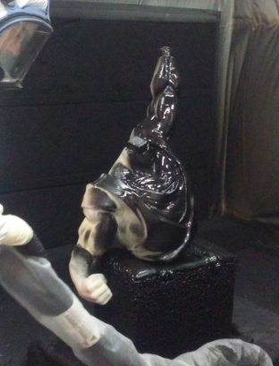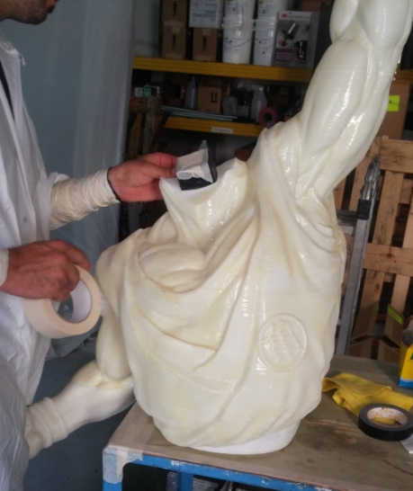

If a single large model is sprayed in parts the connection areas, which must precisely match, should be blocked with tape to prevent from spray reaching them.

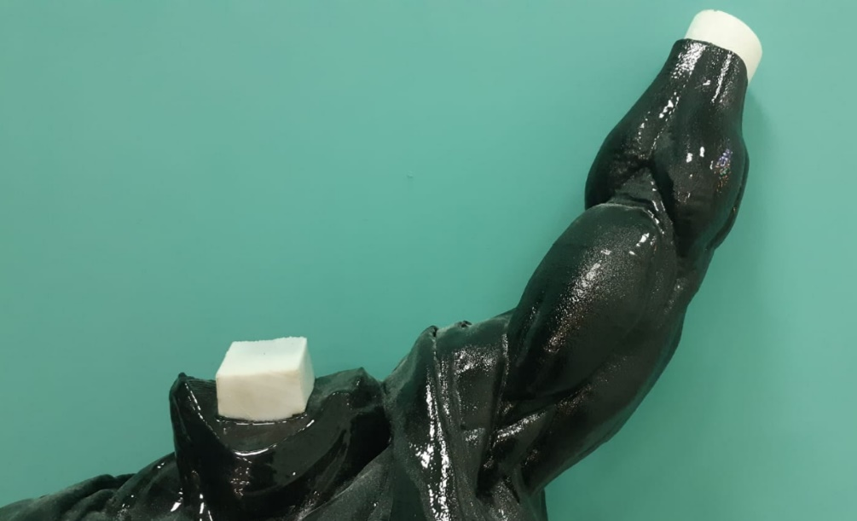

Immediately after spraying, we opened the tape mask. If we had waited, it would never have been cut from the model

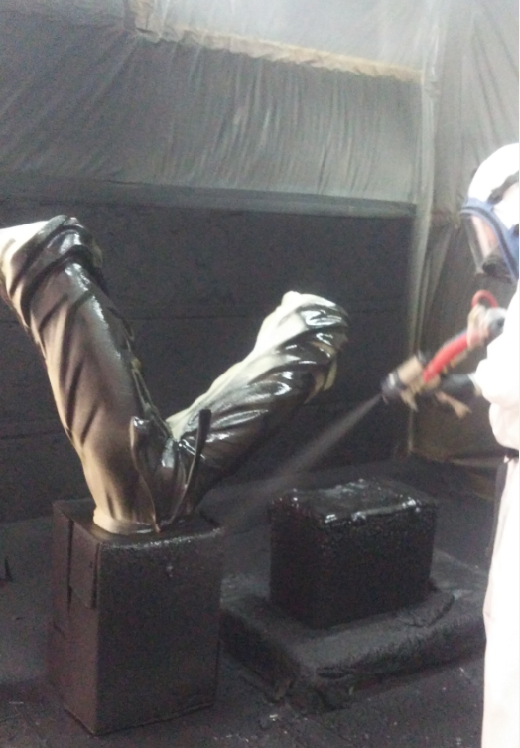

In this example to the model is placed on a platform and the entire work area is covered with plastic. The operator is completely protected

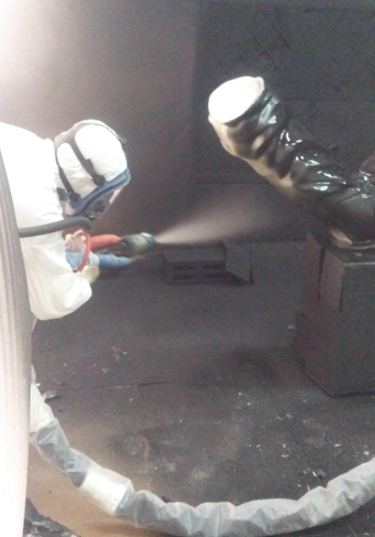

Verify in advance that all sections of the model can be reached.

**Cleanup**

Tools should be scraped clean before the plastic is hard. Denatured alcohol is a good cleaning solvent but must be handled with extreme caution owing to its flammability and health hazards. Work surfaces can be coated with wax or release agent so that cured plastic can be easily removed.

**Finishes & Final touches**

In general, once the object is coated with hot coatingit is already an attractive finished product, and ready for painting.

If needed, it is possible to continue and polish the model for ab even smoother look. Take this into account when choosing the coating material: usually rigid materials can be polished while flexible materials are much harder to polish.

